' Michael Voell

' Baseball Ticket Sales

' 1/19/2016

' Purpose: Compute the cost of baseball tickets depending on what the user chooses using sub procedures.

Option Strict On

Public Class frmBaseballTicketSales

' Class Variables

Private _intClearLabel As String = "Total cost for tickets: $0.00"

Private Sub frmBaseballTicketSales_Load(sender As System.Object, e As System.EventArgs) Handles MyBase.Load

Threading.Thread.Sleep(5000)

End Sub

Private Sub btnClear_Click(sender As System.Object, e As System.EventArgs) Handles btnClear.Click

' Clearing all items and making them all invisible until user selects a ticket type

lblNumberOfTickets.Visible = False

txtNumberOfTickets.Visible = False

txtNumberOfTickets.Clear()

lblSeatType.Visible = False

cboSeatType.Visible = False

btnComputeCost.Visible = False

btnClear.Visible = False

lblTotalCost.Visible = False

lblTotalCost.Text = _intClearLabel

End Sub

Private Sub cboTicketType_SelectedIndexChanged(sender As System.Object, e As System.EventArgs) Handles cboTicketType.SelectedIndexChanged

Dim intTicketType As Integer

' Getting Case Information

intTicketType = cboTicketType.SelectedIndex

Select Case intTicketType

Case 0

' Setting the ticket type depending on what is selected

SeasonTickets()

MakeVisible()

Case 1

' Setting the ticket type depending on what is selected

SingleTickets()

MakeVisible()

End Select

End Sub

Private Sub btnComputeCost_Click(sender As System.Object, e As System.EventArgs) Handles btnComputeCost.Click

' Variables

Dim intAmountOfTickets As Integer

Dim intTicketCost As Integer

Dim intSeatCost As Integer

Dim intTicketType As Integer

' Calculations and Try / Catch

Try

intAmountOfTickets = CInt(txtNumberOfTickets.Text)

Catch ex As OverflowException

MsgBox("Overflow exception. Input number too high.")

txtNumberOfTickets.Clear()

txtNumberOfTickets.Focus()

Catch ex As FormatException

MsgBox("Incorrect format. Please use only numbers.")

txtNumberOfTickets.Clear()

txtNumberOfTickets.Focus()

Catch ex As ArgumentNullException

MsgBox("No input. Please input a number.")

txtNumberOfTickets.Clear()

txtNumberOfTickets.Focus()

Catch ex As Exception

MsgBox("General exception handeled. No output.")

txtNumberOfTickets.Clear()

txtNumberOfTickets.Focus()

End Try

intSeatCost = cboSeatType.SelectedIndex

intTicketType = cboTicketType.SelectedIndex

' Double case... who knew?

' Getting the ticket type

Select Case intTicketType

Case 0

' If the ticket type is a season ticket, set the case values to this

Select Case intSeatCost

Case 0

intTicketCost = CInt(FindTicketCost(2500, intAmountOfTickets))

lblTotalCost.Visible = True

lblTotalCost.Text = "Season Ticket Cost: " & intTicketCost.ToString("C")

Case 1

intTicketCost = CInt(FindTicketCost(1500, intAmountOfTickets))

lblTotalCost.Visible = True

lblTotalCost.Text = "Season Ticket Cost: " & intTicketCost.ToString("C")

End Select

Case 1

' If the ticket type is a single ticket, set the case values to this

Select Case intSeatCost

Case 0

intTicketCost = CInt(FindTicketCost(55, intAmountOfTickets))

lblTotalCost.Visible = True

lblTotalCost.Text = "Single Ticket Cost: " & intTicketCost.ToString("C")

Case 1

intTicketCost = CInt(FindTicketCost(35, intAmountOfTickets))

lblTotalCost.Visible = True

lblTotalCost.Text = "Single Ticket Cost: " & intTicketCost.ToString("C")

Case 2

intTicketCost = CInt(FindTicketCost(25, intAmountOfTickets))

lblTotalCost.Visible = True

lblTotalCost.Text = "Single Ticket Cost: " & intTicketCost.ToString("C")

Case 3

intTicketCost = CInt(FindTicketCost(15, intAmountOfTickets))

lblTotalCost.Visible = True

lblTotalCost.Text = "Single Ticket Cost: " & intTicketCost.ToString("C")

End Select

End Select

End Sub

Private Sub SeasonTickets()

' Adding items to Combo Box

cboSeatType.Items.Clear()

cboSeatType.Text = "Select an Item"

cboSeatType.Items.Add("Box Seats - $2500")

cboSeatType.Items.Add("Lower Deck - $1500")

End Sub

Private Sub SingleTickets()

' Adding items to Combo Box

cboSeatType.Items.Clear()

cboSeatType.Text = "Select an Item"

cboSeatType.Items.Add("Box Seats - $55")

cboSeatType.Items.Add("Lower Deck - $35")

cboSeatType.Items.Add("Upper Deck - $25")

cboSeatType.Items.Add("Standing Room Only - $15")

End Sub

Private Sub MakeVisible()

' Making things visible when a Ticket Type is chosen

lblNumberOfTickets.Visible = True

txtNumberOfTickets.Visible = True

lblSeatType.Visible = True

cboSeatType.Visible = True

btnComputeCost.Visible = True

btnClear.Visible = True

End Sub

Private Function FindTicketCost(ByVal intTicketAmount As Integer, ByVal intNumberOfTickets As Integer) As Decimal

' Variables

Dim intCostTotal As Integer

' Calculations

intCostTotal = intTicketAmount * intNumberOfTickets

' Returning intCostTotal to main sub

Return intCostTotal

End Function

End Class

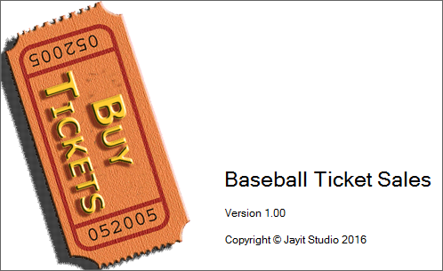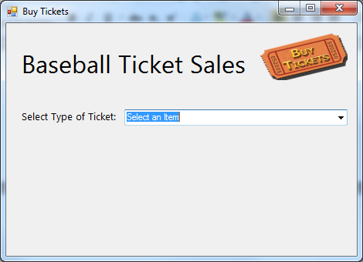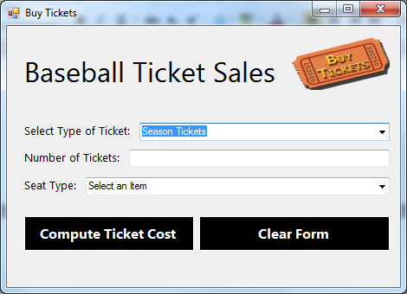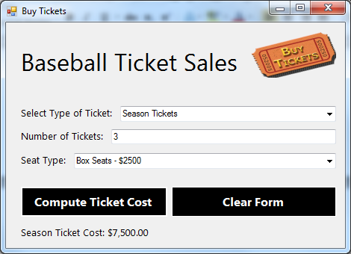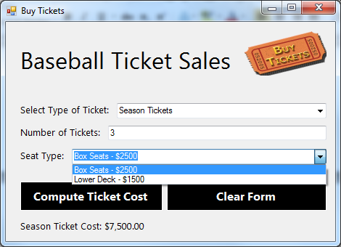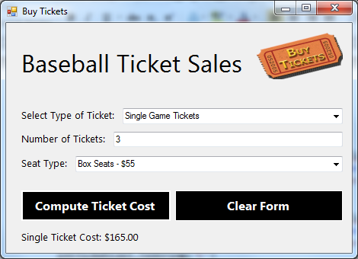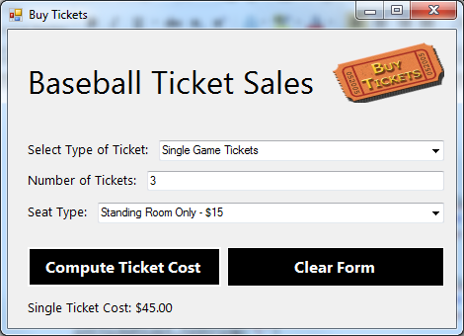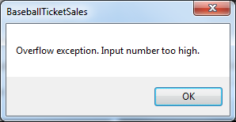

(clear button)

